Project Report

On

MAA KI RASOI

**Tiffin Management System**

Submitted in partial fulfillment for the award of

Online Diploma in Advance Computing

(e-DAC) from C-DAC, ACTS (Pune)



**Guided By:**

Mr. Mukesh Negi

**Presented by:**

# Mr. Akhlesh Gour 200940181019

# Mr. Anand Srivastava 200940181036

**Mr. Ninad Raje 200940181125**

**Mr. Prasad Tulapurkar 200940181141**

**Mr. Viplav Sirsikar 200940181227**

**Centre for Development of Advanced Computing (C-DAC), Pune.**

**ACKNOWLEDGEMENT**

This project “**MAA KI RASOI – Tiffin Management System**” was a great learning experience for us and We are submitting this work to Advanced Computing Training School (CDAC ACTS).

I am very glad to mention *Mr. Mukesh Negi* for his valuable guidance to work on this project. His guidance and support helped us to overcome various obstacles and intricacies during the course of project work.

Our heartfelt thanks goes to *Ms. Shilpi* (Course Coordinator, PG-*DAC*) who gave all the required support and kind coordination to provide all the necessities to complete the project and throughout the course up to the last day here in C-DAC ACTS, Pune.

**From:**

# Mr. Akhlesh Gour 200940181019

# Mr. Anand Srivastava 200940181036

Mr. Ninad Raje 200940181125

Mr. Prasad Tulapurkar 200940181141

Mr. Viplav Sirsikar 200940181227

**TABLE OF CONTENTS**

1. Introduction……………………………………………………………………………………….4
2. Project Overview………………………………………………………………………………..5
   1. Purpose………………………………………………………………………………………..5
   2. Scope……………………………………………………………………………………………5
   3. Feasibility……………………………………………………………………………………..5
      1. Technical Feasibility…………………………………………………………….5
      2. Operational Feasibility…………………………………………………………6
      3. Economical Feasibility………………………………………………………….6
3. Overall Description……………………………………………………………………………..7
   1. Product Features…………………………………………………………………………..7
   2. Technology Used…………………………………………………………………………..7
   3. User Classes…………………………………………………………………………………..7
   4. General Constraints……………………………………………………………………….8
   5. Architecture Diagram…………………………………………………………………….8
4. Software Requirements Specifications…………………………………………………9
   1. Functional Requirements……………………………………………………………….9
   2. Administrator Task……………………………………………………………………….11
   3. User Task………………………………………………………………………………………13
   4. Software Quality Attribute……………………………………………………………15
   5. System Requirements…………………………………………………………………..15
      1. Hardware Requirements……………………………………………………..15
      2. Software Requirements……………………………………………………….15
5. Design…………………………………………………………………………………………………14
   1. Database Design……………………………………………………………………………14
   2. ER Diagram……………………………………………………………………………………16
   3. Class Diagram…………………………………………………………………………….….17
   4. DFD-0 Diagram………………………………………………………………………………17
   5. DFD-1 Diagram………………………………………………………………………………18
   6. DFD-2 Diagram……………………………………………………………………………...19
   7. Use Case Diagram………………………………………………………………………….20
6. Interfaces……………………………………………………………………………………………21
7. Test Reports……………………………………………………………………………………….32
8. Future Scope………………………………………………………………………………………33
9. References………………………………………………………………………………………….33

**1. Introduction**

These are times when bachelors including other customers, find it difficult to curb their hunger and cravings in a tight budget when relocating to a new city.

So many times, the bachelors and customers get bored of eating same food day in and day out regularly and look out for ways to keep spice in their daily eating habits and eternal satisfaction.

The project **MAA KI RASOI - Tiffin Management System** is a web-based application that allows the administrator to handle all the activities online quickly and safely. Using Interactive GUI anyone can quickly learn to use the complete system.

Using this, the administrator doesn’t have to sit and manage the entire activities on paper, and at the same time, the head will feel comfortable to keep check of the whole system. This system will give him power and flexibility to manage the entire system from a single online portal.

The project aims to provide food services to the customers (Bachelors), who find it difficult to curb their hunger in a tight budget. As we know that the food cooked at home is hygienic and best for health. The food prepared at home is cheaper too and keeps the doctors far away and makes us healthy.

In today’s world, most of the people live away from their homes for work. Food is the basic necessity for everybody. Most of them are dependent on other people for food, so the aim of the project is to provide them hygienic home-cooked food of high quality at low cost.

Various items are available to the customers. They can select the desired package at a reasonable price. The food can be delivered to their residence. They can pay on the basis of their respective selected packages.

We make sure that all the Homemakers use fresh vegetables, fresh wheat, rice etc. The food is prepared by the homemakers in their well sanitised and hygienic kitchen, just like our homes to maintain the hygiene, taste and quality.

The customer can choose the package of their own choice. So, we have generated a system that will provide package details to the customers, i.e., Mini, Classic and Jumbo Package. The Tiffin will be delivered at their residence at the time given by the customers.

**2. Project Overview**

**2.1 Purpose:**

This project is to book a service online. Using this system, the customer (bachelor) can do booking of Maa Ki Rasoi services from anywhere.

This document gives the brief summary of the system Maa Ki Rasoi. It will be helpful for the developer to actually outline the system.

**2.2 Scope:**

The Maa Ki Rasoi – Tiffin Management System is a software application to assist a user (individual or society) for placing orders, which includes selecting a Homemaker, selecting the package which he/she wants to avail, ordering and cancelling/rescheduling orders. If user has any queries or facing any problem then he/she can ask for help from About Us/Contact Us section.

In Admin part, he/she can add/remove customers, add/remove homemakers, give the solutions to the user’s queries and keep the track of all the orders of all the users.

The system provides a user-friendly environment to order a suitable package. Also provides all the information of each food-package.

**2.3 Feasibility:**

A feasibility study is an analysis that takes all of a project's relevant factors into account—including economic, technical, and scheduling considerations—to ascertain the likelihood of completing the project successfully.

A feasibility study is simply an assessment of the practicality of a proposed plan or project.

The following feasibility studies were conducted to make sure that our software is feasible:

**2.3.1 Technical feasibility:**

As per this study, we found that our choice of technology stack was conducive enough to bring the project to fruition. Irrespective of the system in which our backend ran, the results were as expected and platform dependency was not found.

In the type of feasibility study, the system analyst has to check whether it is possible or not to develop the requested system with availability of manpower,

software, hardware, etc…The system which we run in Linux as well as windows platform and hence are suitable for the end-user. The system is technically feasible because it does not require too much manpower and runs with the basic available equipment.

**2.3.2 Operational feasibility:**

As per this study, we came to the conclusion that system is user friendly and easy to maintain. The project offers a great deal of user experience and convenience to the target group.

We need to train our staff so that system will be handled efficiently. As the system developed is very user-friendly and easy to operate for any person with minimum computer knowledge is also able to handle our system. It is also easy to operate due to the user-friendly interface developed using React JS, JavaScript and their respective libraries.

**2.3.3 Economical feasibility:**

As per this study, we concluded that the technology stack we are using in our project is open sourced, freely available and well-maintained by the community. This reduces the cost of system as well as development cost, without compromising the quality of the product. This system was found to be ergonomic to the target customer base.

**3. Overall Description**

**3.1 Product Features:**

The main feature of this system is the user can search for the particular food-package he wants and particular home-maker as well. The user must be a registered one before he orders a package. The user can change/cancel the order as per his need. The system shows the details of that package, payment amount and it’s summary after selecting the package and all the items user wants to see. There are 3 types of food-packages Mini package, Classic Package and Jumbo Package. User can see all his/her order history and all his/her homemakers in this system. Also, if user has any queries or is facing any issue, he can ask for help from About Us/Contact Us section.

In admin part, he/she can add or remove the Homemakers and Customers in the system. Admin can give the solutions to the user queries and keep track of all the orders of all users.

**3.2 Technology Used:**

**BACK END:**

Spring Boot

JPA Repository

MySQL database

Apache Tomcat

Spring REST

**FRONT END:**

Spring MVC

React

HTML, CSS, Bootstrap

JavaScript

Apache Tomcat

**3.3 User Classes:**

There are three types of users to this system, one is Customer, another one is Admin and last one is Homemaker. Their functionalities are as follow:

**ADMIN:** The super user, admin class represents complete authority over the system. An admin can,

1. Add or remove the customers on system
2. Add or remove the homemakers on system
3. Handle the queries and give solutions to all the queries which are coming from users/customers/homemakers
4. Keep track of all the orders of all the users

**CUSTOMER:** Once customer has registered in this system he/she can,

1. Select the package which he’s willing to choose
2. Choose the desired homemaker
3. Add his additional information
4. Choose the food package and desired homemaker which he wants to select
5. Choosing the payment mode (UPI/Credit-Debit CARD/Pay on Delivery) and pay according to that
6. Cancel the order if he/she wants to, also he/she can get refund for the same if he/she has paid for that
7. Ask queries if he/she is facing any issues

**HOMEMAKER:** Once homemaker has registered in this system, he/she can,

1. Can see the customers
2. Can see the orders
3. Handle the queries and give solutions to all the queries which are coming from admin
4. Keep track of all the orders of their respective customer

**3.4 General Constraints:**

The “Maa Ki Rasoi” should run on all Internet Browser and all processors which

supports the Internet Browser.

**3.5 Architecture Diagram:**

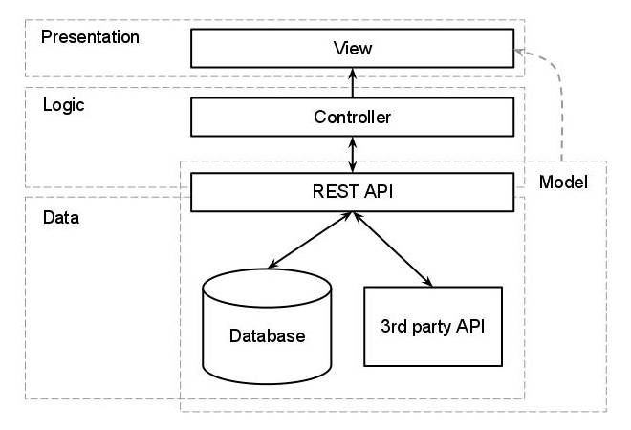

4. Software Requirements Specification

**Introduction:**

This document is the SRS report for a *Tiffin Management System (Maa ki Rasoi)* web Application.

This system has the following main components:

1. Implement the different types of user – Administrator, Customer and Homemaker
2. Implement subscription facility for customer
3. Implement daily menu selection facility from Homemakers; Customers can select their menu accordingly
4. Management of tiffin orders
5. Payment Management for Customer and Homemaker

**Purpose:**

The purpose of our application is to create a platform which provides an opportunity to the local-area homemakers to start their own Tiffin Services while ensuring the local-area bachelors diminish their hunger on a budget.

The users of our web-application will need to create an account as a customer to avail Tiffin Services based on the availability of the Homemaker in the respective locality.

Customers can navigate through different categories of food items as per their choice.

A payment functionality will be built in to allow the use of credit cards, debit cards or COD for customers.

**Scope:**

This system will allow Secure registration and profile management facilities for Customers and Homemakers. System will display numerous Tiffin Services by various homemakers so that the customers can choose their service. Safe payment gateways will be provided by the system so that customer data remains confidential/.

**Definitions**:

**TMS -->** Tiffin Management System

**SRS -->** Software Requirement Specification

**COD -->** Cash on Delivery

**Overview**:

This is a Tiffin Management System that tends to provide Tiffin Services to the Customers (Bachelors) and simultaneously provide Employment to the Homemakers.

**Functional Requirement:**

This section provides a requirement overview of the system. Various functional modules that can be implemented by the system will be-

1. **Customer Authentication and Registration:**

* This system will create a customer profile by providing customer registration functionality
* Customers can create or update his/her profile information
* System will also authenticate user credentials if the customer is already registered

1. **HomeMaker’s Authentication and Registration:**

* This system will allow HomeMaker to create profiles by providing HomeMaker’s registration functionality.
* HomeMaker’s can create or update his profile information.
* System will also authenticate user credentials if HomeMaker is already registered.

1. **Tiffin Catalog:**

* System will provide various categories of Tiffin Services for Customers
* Customers can Choose any Tiffin Service according to his/her Choice
* Product reviews and rating will be available for each product for Customers

1. **Order Processing:**

* System will allow customers to place orders for particular Services, the orders will be available for customers till the confirmation
* System will provide a facility for customers to cancel Service after the confirmation
* Order history will be maintained for each end user

1. **Billing:**

* System will display available payment methods for payment processing
* Customer can choose his/her method of payment for orders

**Hardware Interface:**

* Since the application is internet based, all the hardware shall be required to connect to the internet

**Software Interface:**

* As the system is on server, so requires any scripting language JSP etc.
* System will require a capable Database like MySQL, Oracle etc.
* System will communicate with the database for storing customer profile, product details, Payment history, order history,etc.

**Non-Functional Requirements:**

1. **Usability**: System will be efficient to use, easy to use. Information about best tiffin services offered by homemakers will be given to customers.
2. **Portability**: This system can be used on Windows or Linux OS. System is easy to port on any other server.
3. **Performance**: The Tiffin Management System has adequate performance requirements. it does not take more than 5 seconds to load new pages.
4. **Integrity**: Whenever the changes are made related to customer data and his orders, it shall be reflected in the database as well.

**System Interactions:**

1. **Customer Interaction:** Customers will be able to surf for the required tiffin plans in his location through the website. System will allow the end user to subscribe to the weekly/monthly tiffin plans if he/she is a registered user. Customers will be able to opt out of the order if required. Payment can be made by any one COD, Debit card or UPI.
2. **Homemaker Interaction:** Homemakers can provide their daily menu and can see their daily orders to fulfil.

**Admin Staff**: System Admin will Add/Delete/Update the Customers and Homemakers details. Admin can also manage the payment related issues.

**5. Design**

**5.1 Database Design**

The following table structures depict the database design.

**Table 1: Admin**

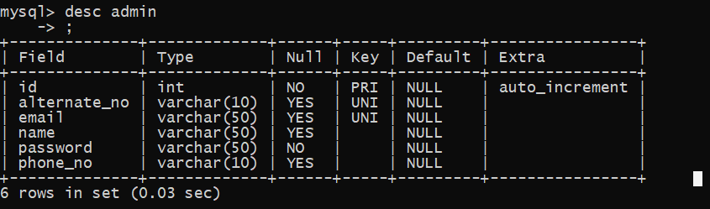

**Table 2: Customer**

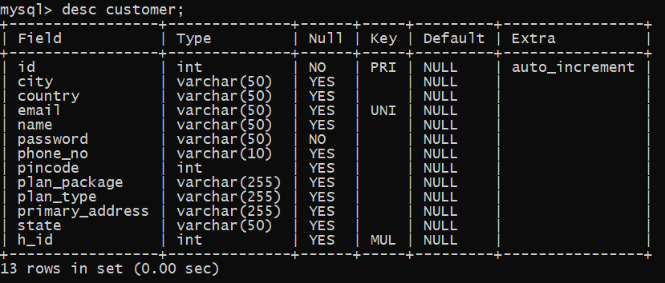

**Table 3: HomeMaker**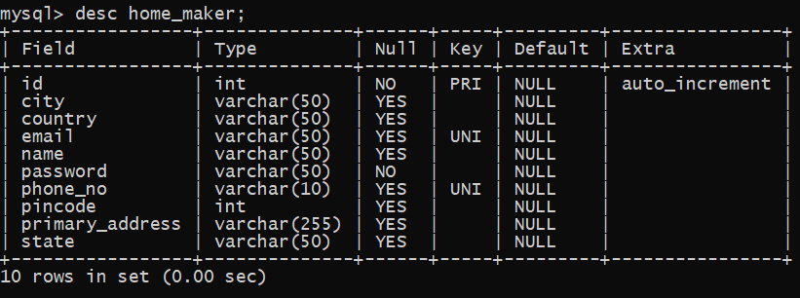

**Table 4: Orders:**

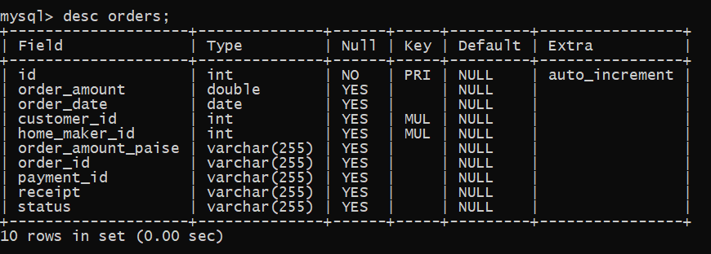

**5.2 ER Diagram**

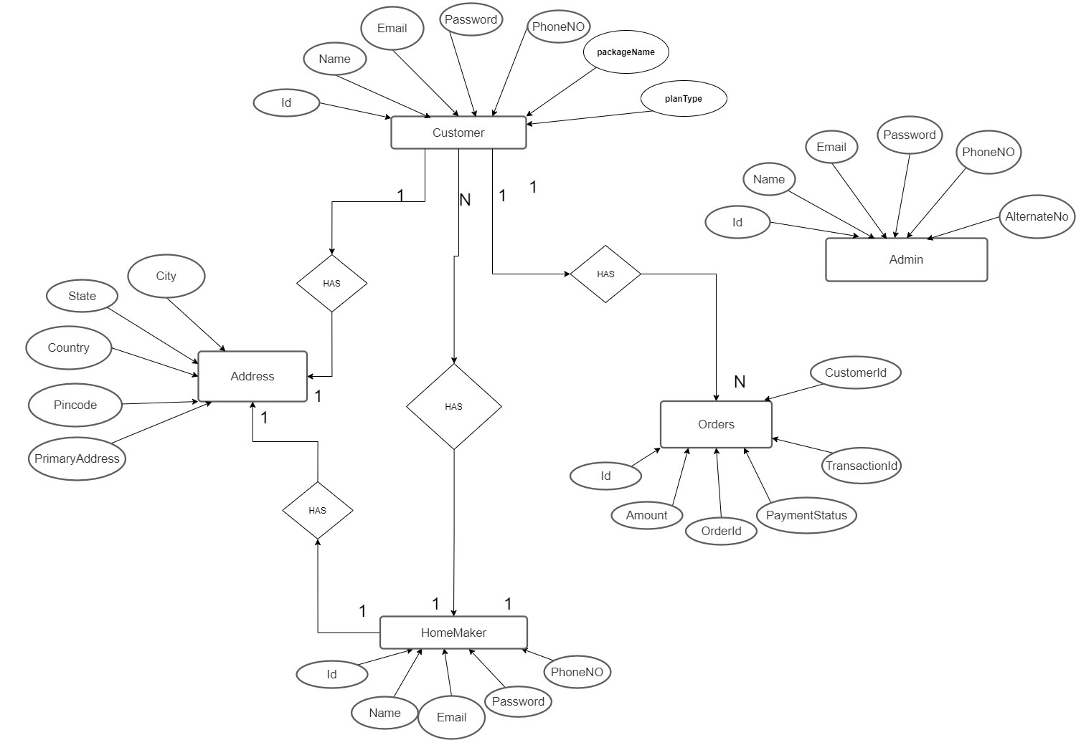

**5.3 Class Diagram**

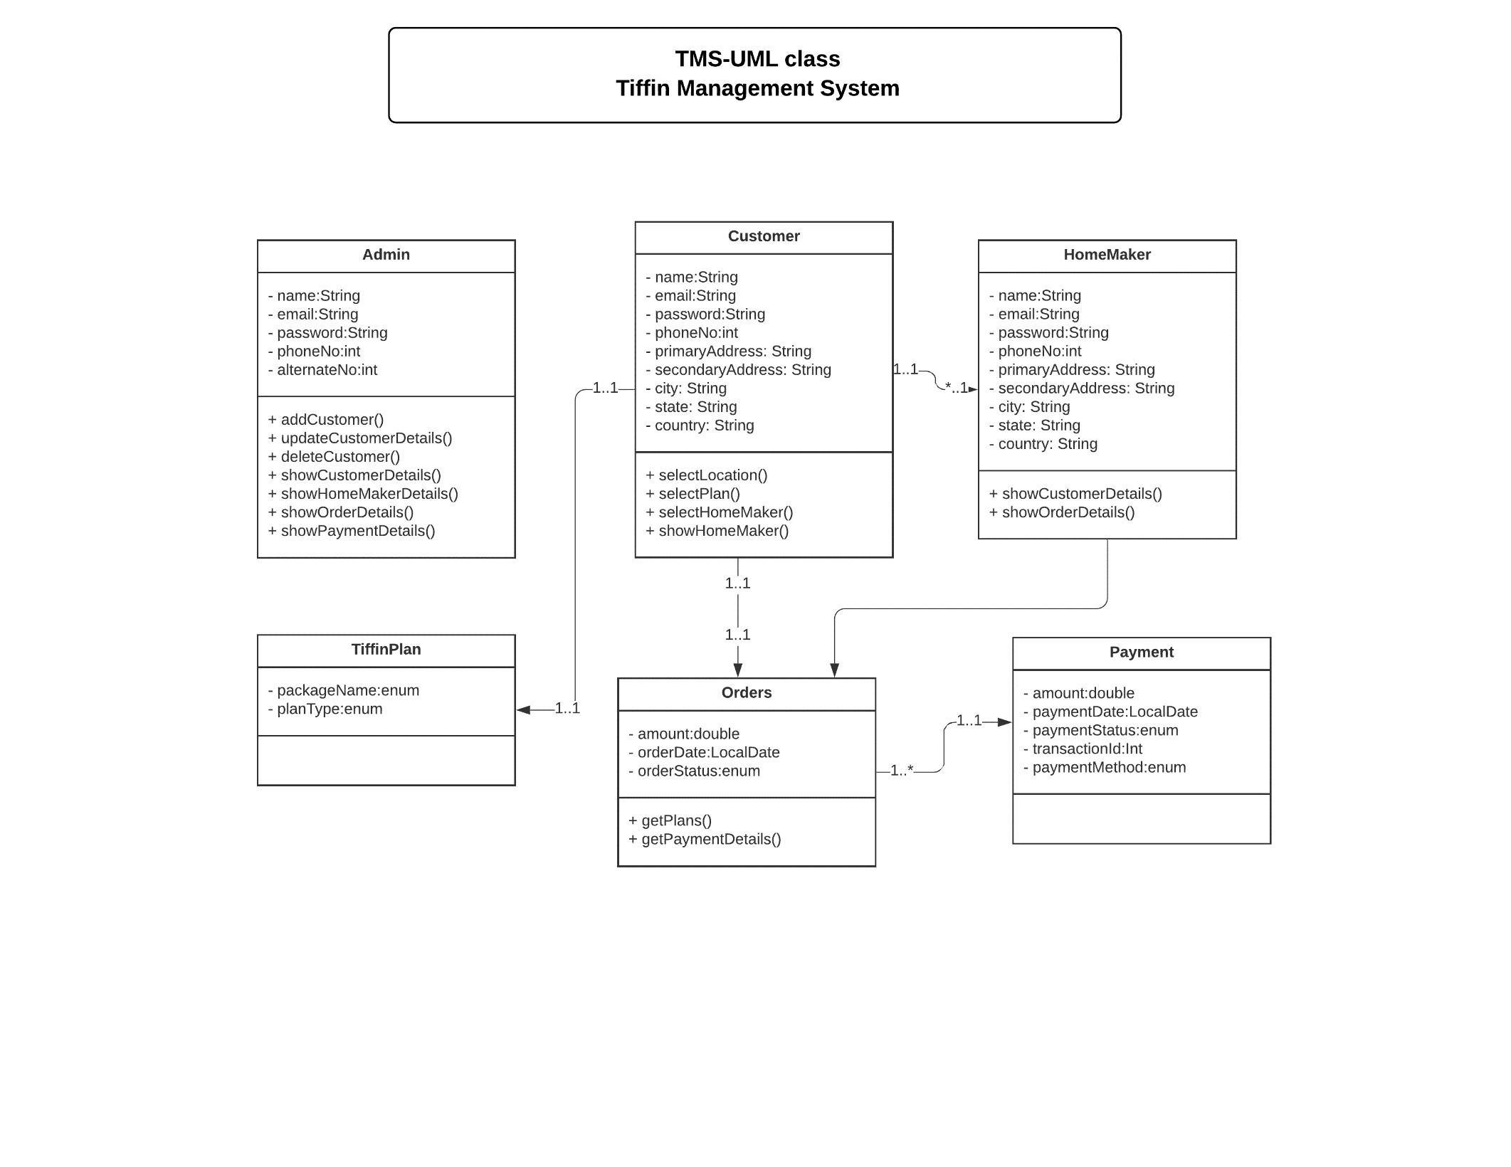

**5.4 DFD-0 Diagram**

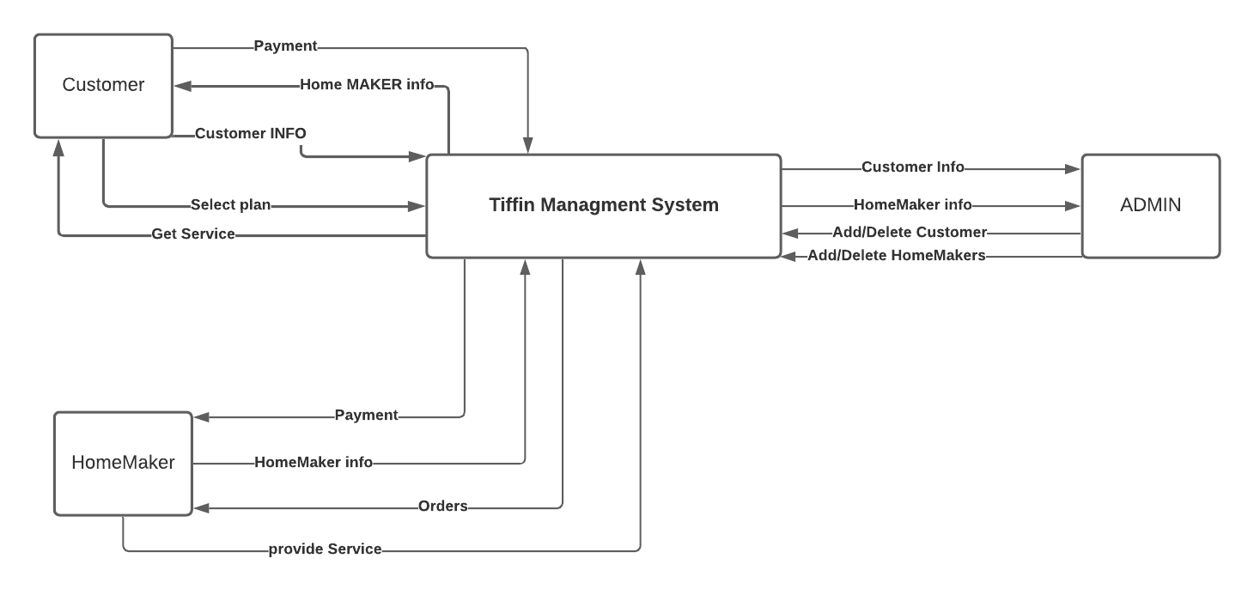

**5.5 DFD-1 Diagram**

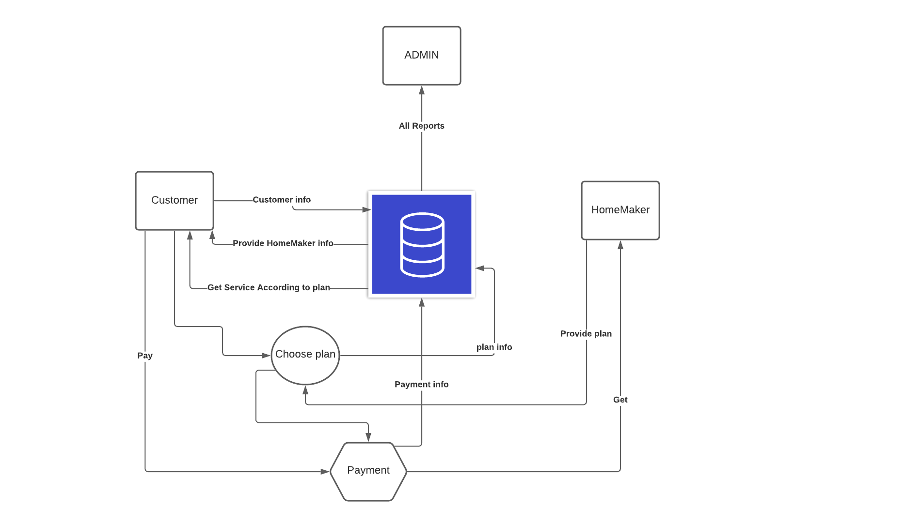

**5.6 DFD-2 Diagram**

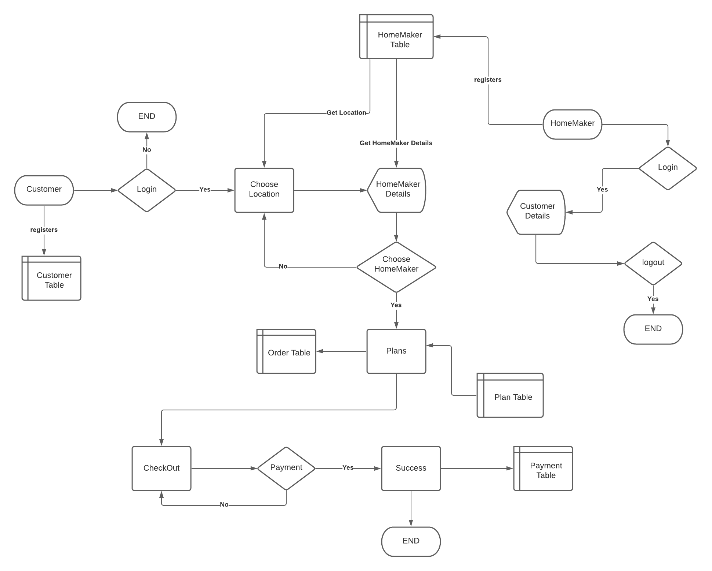

**5.7 Use Case Diagram**

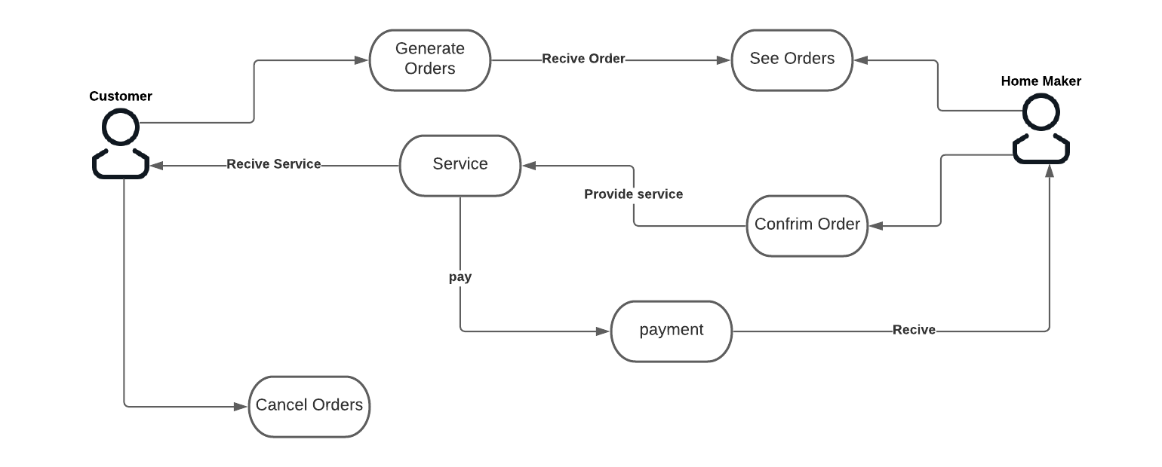

**6. Interfaces**

Home Page:

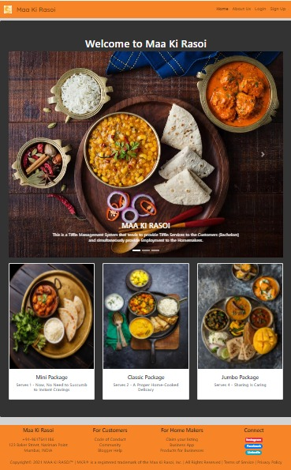

Login Page:

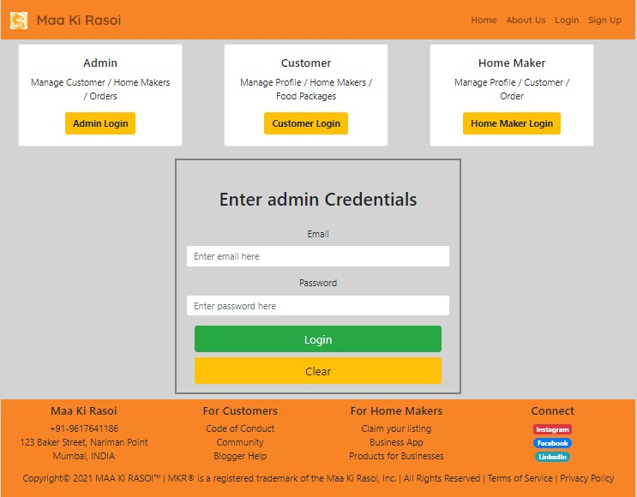

Customer Signup:

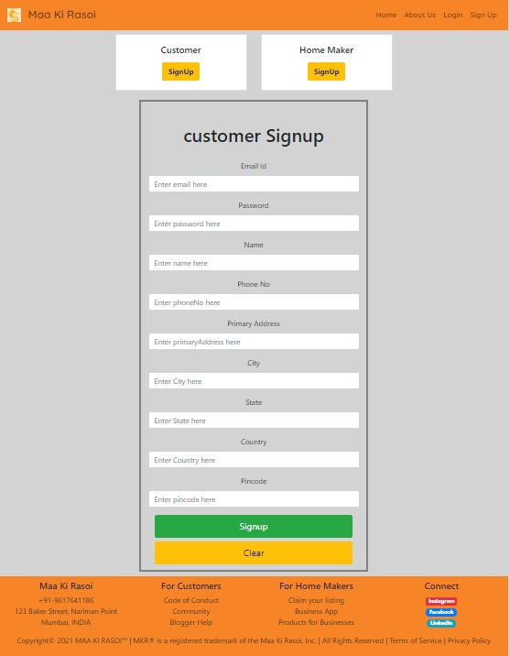

Admin Home:

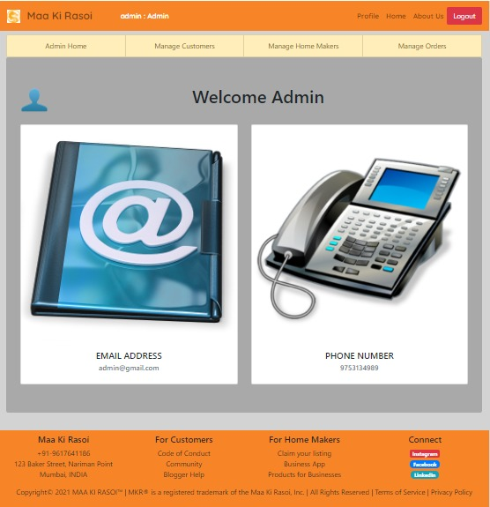

Customer Profile:

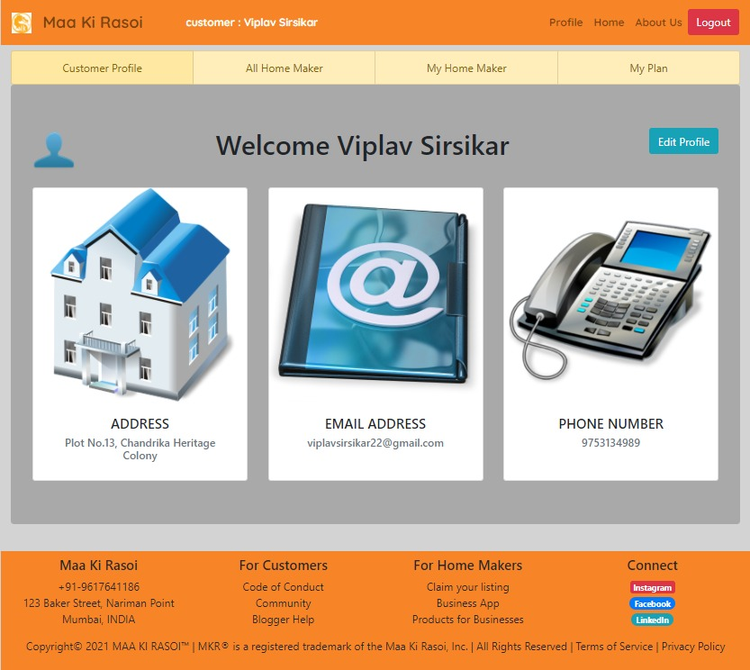

About Us:

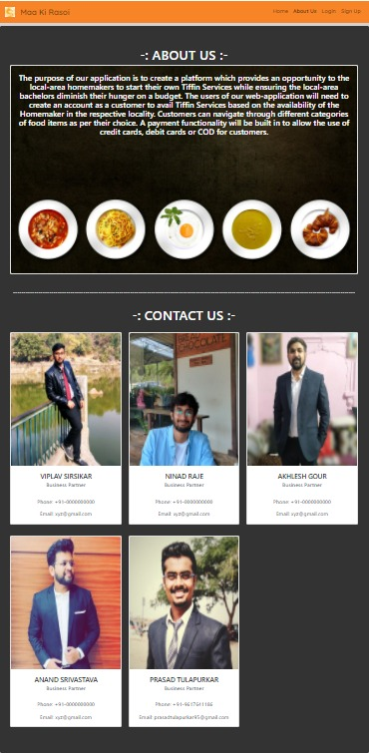

Food Plan Package:

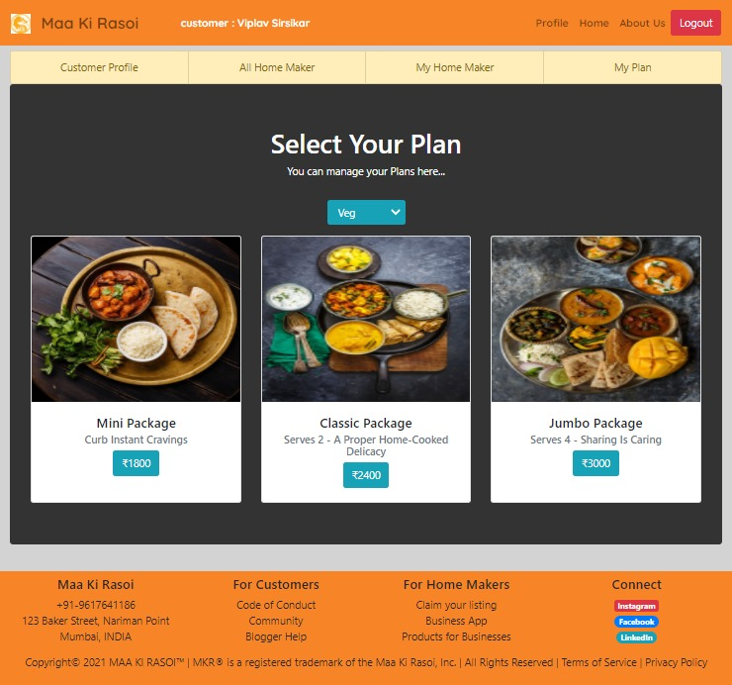

HomeMaker Profile:

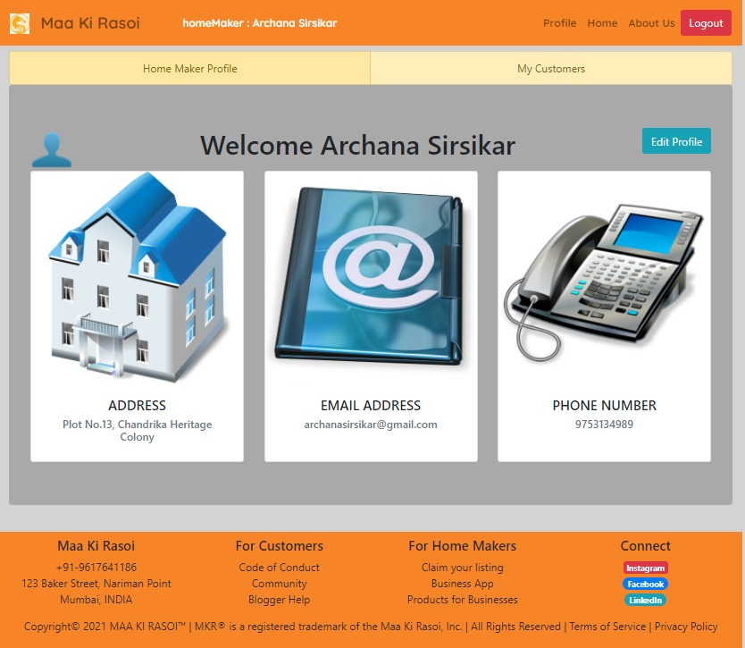

Payment Initiated:

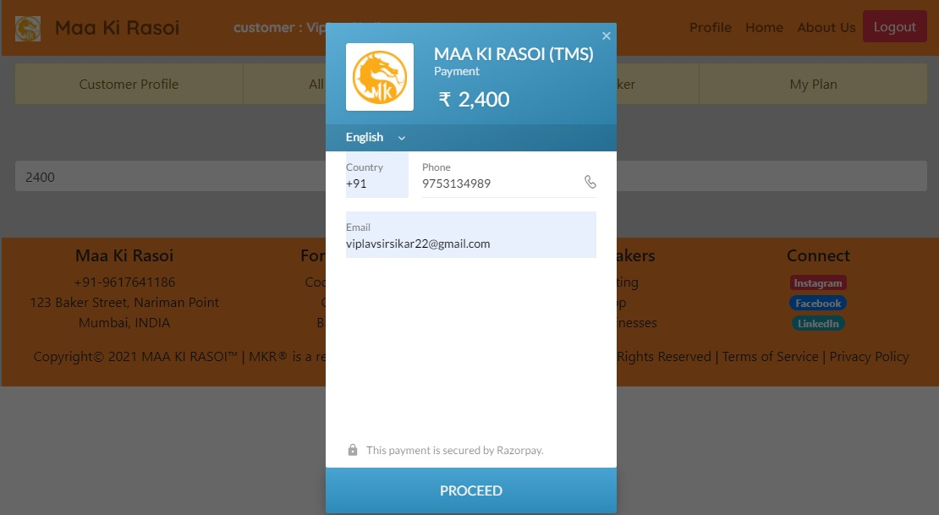

Payment Success:

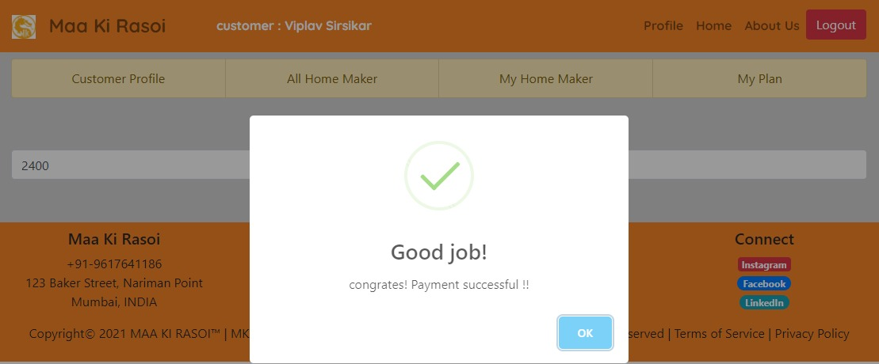

Manage Orders Admin:

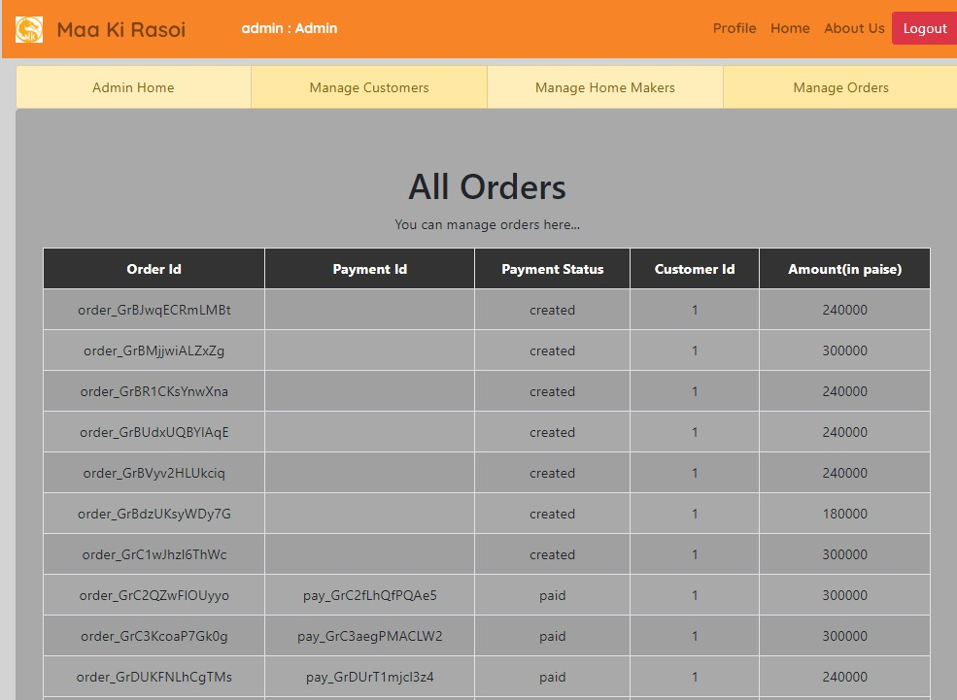

**7. Test Reports**

**The test of report is given here under:**

|  |  |  |  |  |  |
| --- | --- | --- | --- | --- | --- |
| **Sr. no** | **Test Case Title** | **Description** | **Expected Outcome** | **Error Message** | **Result** |
| 1 | Login Page-Admin | If User email=Admin email,  Password= Admin Password | If Validated allow for Admin Home Page  If not redirect to same page | Username and password required | Passed |
| 2 | Login Page –User | If User email=User email,  Password= User Password | If Validated allow for User Home Page  If not redirect to same page | Username and password required | Passed |
| 3 | Show Details of user | Admin can see status of given user. | User Details | No Error | Passed |
| 4 | New user registration | Should not allow any control to be empty if not null and OTP sent & verified the user. | If validated Allow to go to login page | Validation Error | Passed |
| 6 | Log out | User / Admin can logout by using Logout link | Successfully logout message | No Error | Passed |

**8. Future Scope**

1. Live tracking of customer’s order

2. Forgot Password

3. Messaging Services.

4. Delivery Service Integration

**9. References**

* <https://reactjs.org/>
* <https://reactstrap.github.io/>
* <https://spring.io/projects/spring-boot>
* <https://docs.oracle.com/en/java/>